Maxim Manin

Robotics II

11/10/2020

Transistors and switches can be used to make logic gates. Using logic gates, a half adder can be formed, and using another half and an OR gate, a full adder is created. The full adder takes multiple inputs adds them and then outputs the binary addition. A visualization of an 8-bit adder can be demonstrated with lightbulbs

<https://www.youtube.com/watch?v=VBDoT8o4q00>

One of the functions of a computer can be found within the full adder, which takes three inputs (binary, so ones or zeros), adds them, and outputs the sum and the carry if there is one. By combining many of these in a ripple carry adder, data of values counts up input. This uses two logic gates, XOR, and AND, which makes up a half adder, which when put with another half adder and an OR gate makes up a full adder. This makes up part of the computing of a computer.

Charles Babbage’s Analytical Engine (Incomplete at time of death)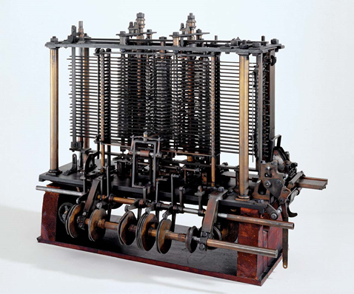

The Analytical Engine was to be a general-purpose, fully program-controlled, automatic mechanical [digital computer](https://www.britannica.com/technology/digital-computer). It would be able to perform any calculation set before it. It was only partially built at the time of Babbage's death in 1871 and later completed in 1910. It ran on instructions through punch cards and was steam powered. It had 4 components: the mill, the store, the reader, and the printer.